1. Write the following plural nouns

Beaches

Skies

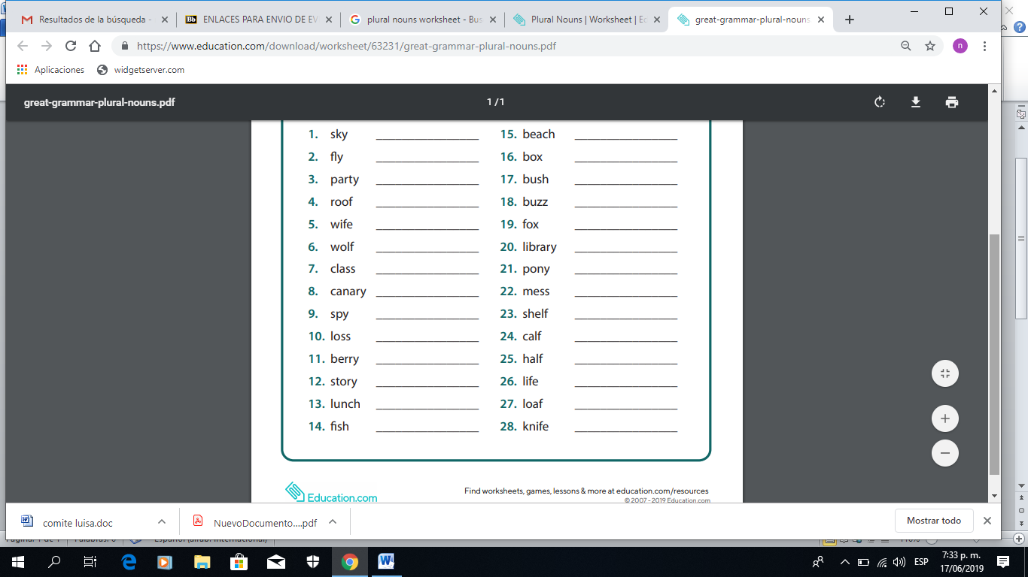

Boxes

Bushes

Buzzes

Foxes

Libraries

Wolves

Wives

rooves

Parties

Flies

1. Complete the sentences with the correct POSSESIVE ADJECTIVE

1. ***The boy*** likes ___his___ school.

2. ***Mary*** sees ___her___ mother every day.

3***. My teachers*** bring ___his­­­___ children to our place on Saturdays.

4. ***The cat*** eats ___it´s___ food quickly.

5. ***I*** often forget ___my___ key.

6. ***You*** write in ___your___ book in class.

7. ***We*** bring ___our___ pencils to class.

8. ***The men*** always bring ___his___ wives to the party.

9. ***Mr. Adams*** teaches ___his___ class in the morning.

10. ***She*** likes to give presents to ___her___ grandchildren.

1. Rewrite the sentences replacing the highlighted word with the correct PERSONAL PRONOUN
2. **The bus** is big = **It** is big___
3. **You and Ron** are happy = ___**You** are happy___
4. **The doctors** are at the hospital = ___**They** are at the hospital___
5. **Lisa** is a teacher = ___**She** is a teacher___
6. **Dan** is at school = ___**He** is at school___
7. **The car** is white = ___**It** is white___
8. **Carlos and I** are friends = ___**We** are friends___
9. **The houses** are clean = ___**They** are clean___

1. Write A or AN according to the noun

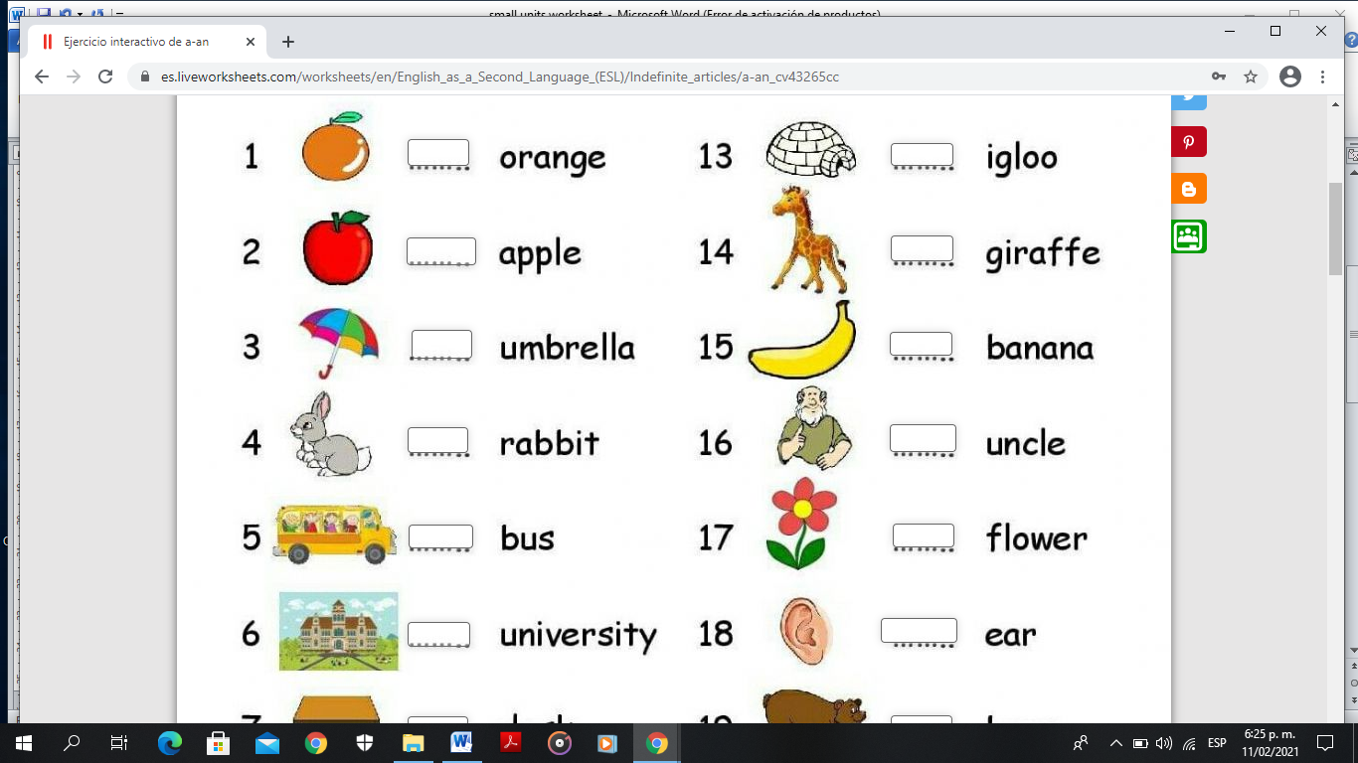 

A

A

A

A

A

A

An

An

An

An

An

An

1. Write THE when it is necesary

**The** guitar

___ basketball

___ Mickey Mouse

___ blue

___ Monday

**The** Browns

**The** Pacific Ocean

**The** animals

**The** moon

**The** USA